**1.Write a Python program to count the occurrences of each word in a given sentence.**

def word_count(str):

counts = dict()

words = str.split()

for word in words:

if word in counts:

counts[word] += 1

else:

counts[word] = 1

return counts

print( word_count('the quick brown fox jumps over the lazy dog.'))

**output:**

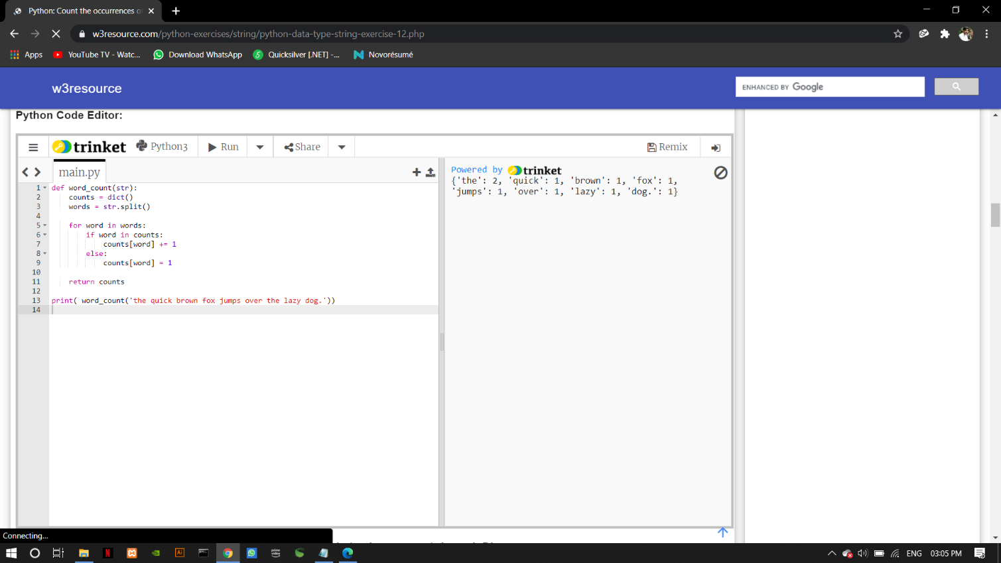

**2. Write a Python program to remove duplicates from a list**

a = [10,20,30,20,10,50,60,40,80,50,40]

dup_items = set()

uniq_items = []

for x in a:

if x not in dup_items:

uniq_items.append(x)

dup_items.add(x)

print(dup_items)

**output:**

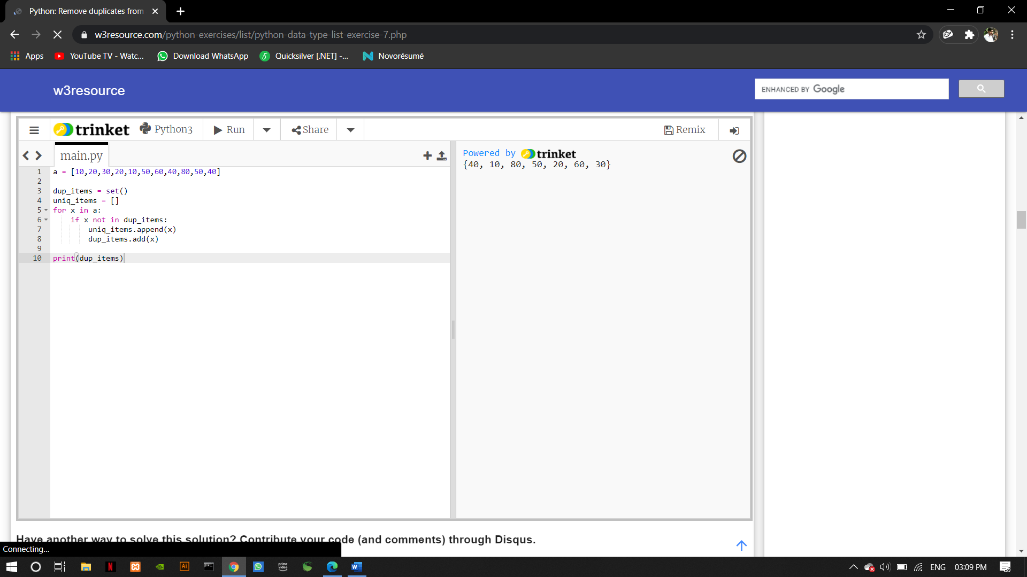

**3.Write a Python program to count the number of elements in a list within a specified range.**

def count_range_in_list(li, min, max):

ctr = 0

for x in li:

if min <= x <= max:

ctr += 1

return ctr

list1 = [10,20,30,40,40,40,70,80,99]

print(count_range_in_list(list1, 40, 100))

list2 = ['a','b','c','d','e','f']

print(count_range_in_list(list2, 'a', 'e'))

**output:**

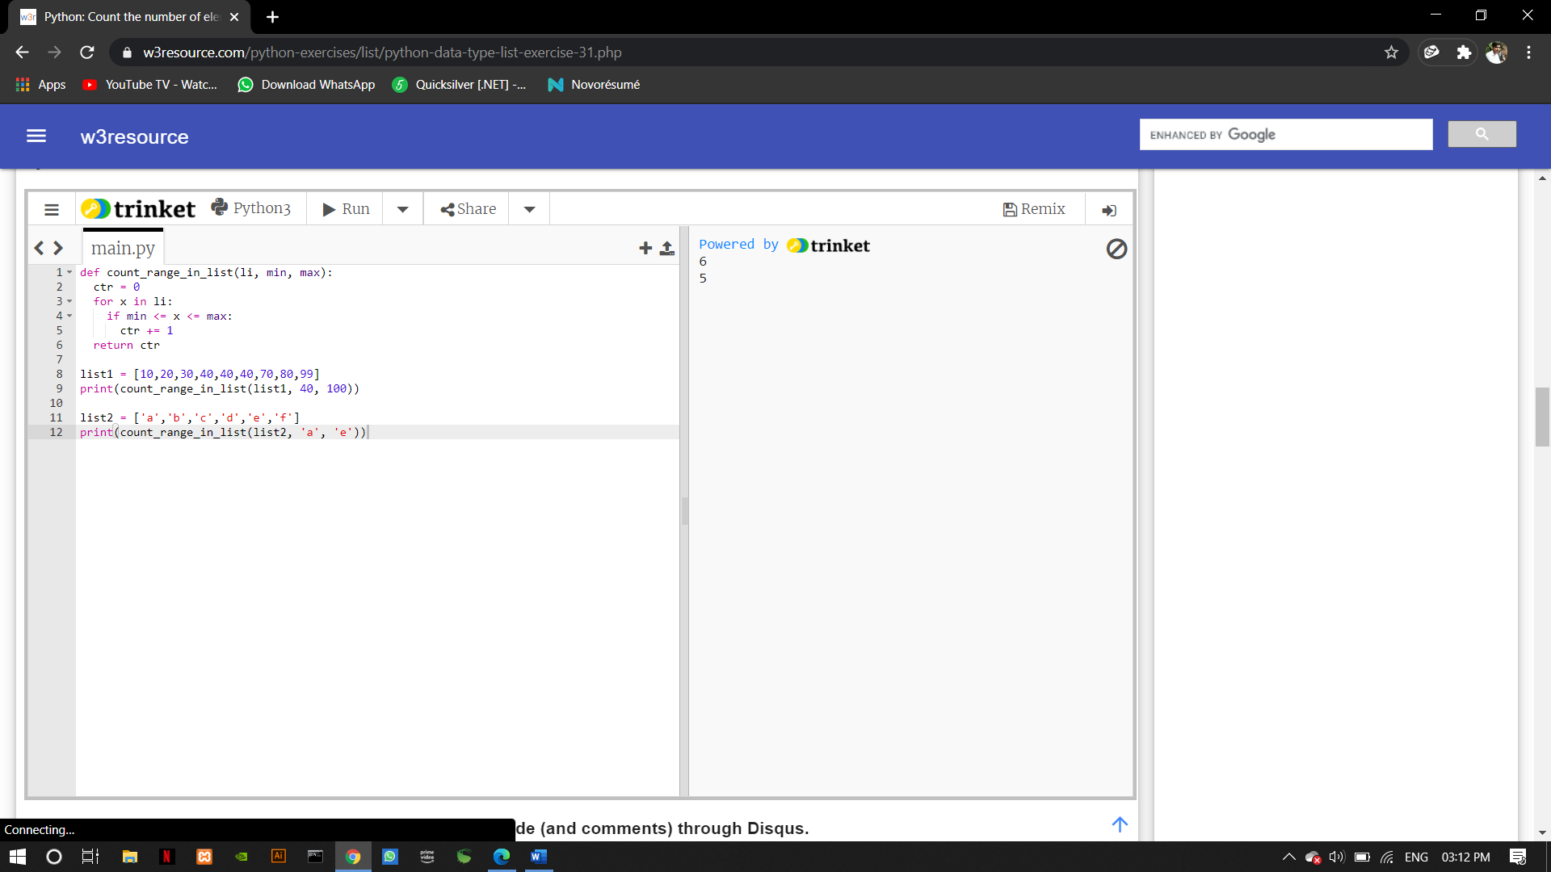

**4.** **Write a Python script to merge two Python dictionaries**

d1 = {'a': 100, 'b': 200}

d2 = {'x': 300, 'y': 200}

d = d1.copy()

d.update(d2)

print(d)

**output:**

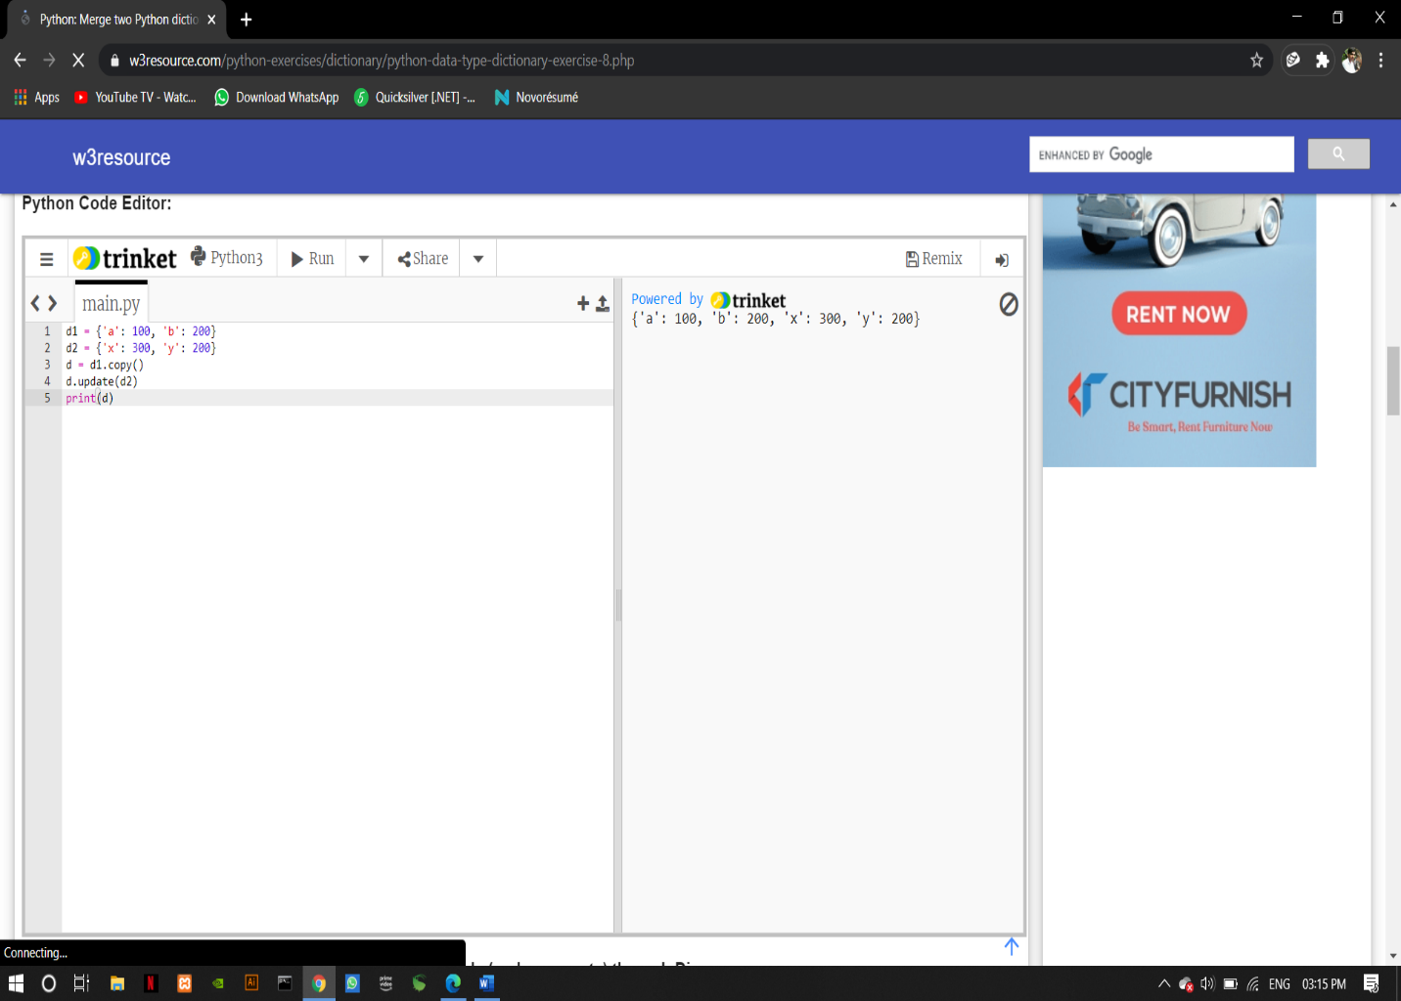

**5.** **Write a Python program to find the highest 3 values in a dictionary**

from heapq import nlargest

my_dict = {'a':500, 'b':5874, 'c': 560,'d':400, 'e':5874, 'f': 20}

three_largest = nlargest(3, my_dict, key=my_dict.get)

print(three_largest)

**output:**

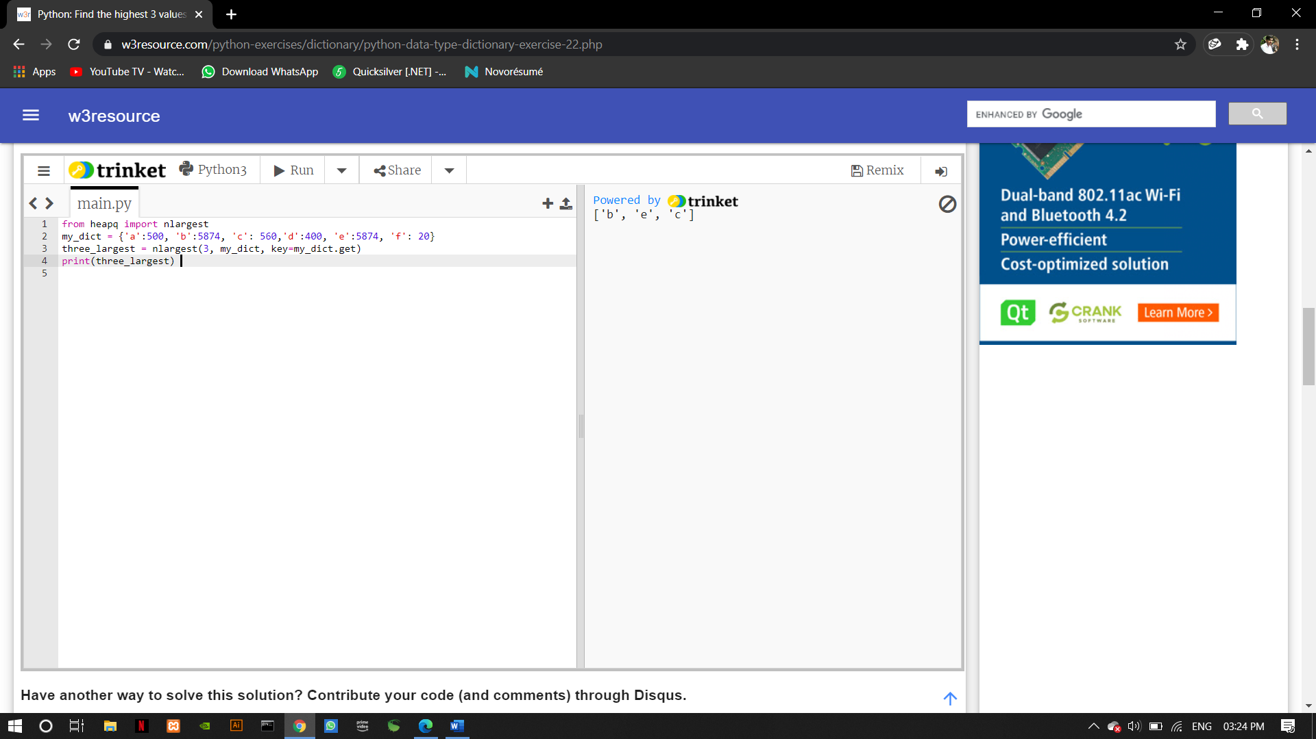

**6. Write a Python program to convert a tuple to a string.**

tup = ('e', 'x', 'e', 'r', 'c', 'i', 's', 'e', 's')

str = ''.join(tup)

print(str)

**output:**

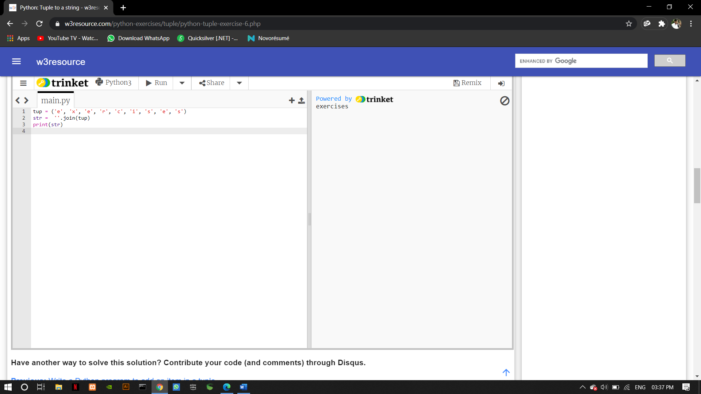

**7. Write a Python program to reverse a tuple.**

x = ("KIRAN")

y = reversed(x)

print(tuple(y))

**output:**

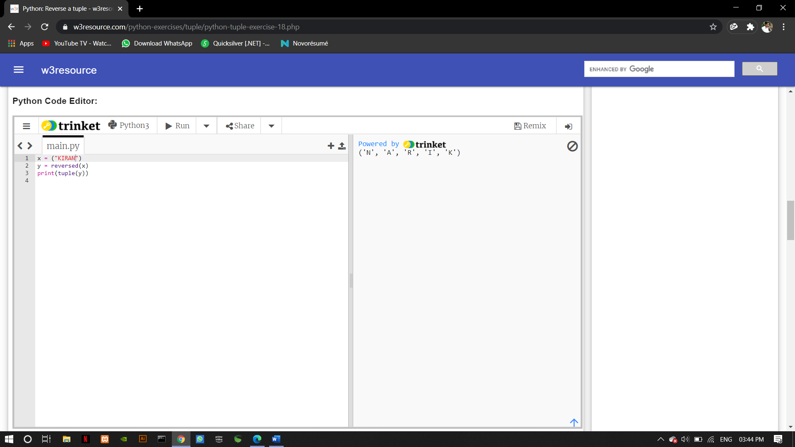

**8. Write a Python program to remove existing indentation from all of the lines in a given text.**

import textwrap

sample_text = '''

Python is a widely used high-level, general-purpose, interpreted,

dynamic programming language. Its design philosophy emphasizes

code readability, and its syntax allows programmers to express

concepts in fewer lines of code than possible in languages such

as C++ or Java.

'''

text_without_Indentation = textwrap.dedent(sample_text)

print()

print(text_without_Indentation )

print()

**output:**

